[**VISUAL PHYSICS ONLINE**](http://www.physics.usyd.edu.au/teach_res/hsp/sp/spHome.htm)

**MODULE 7 NATURE OF LIGHT**

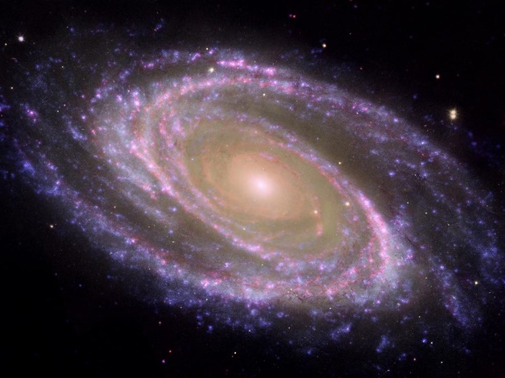

**ELECTROMAGNETIC WAVES**

**SPECTRA PRODUCED BY DISCHARGE TUBES**

**CATHODE RAYS (electron beams)**

* Streams of electrons (negatively charged particles) observed in **vacuum tubes** or **discharge tubes** (evacuated glass tubes that are equipped with at least two metal electrodes to which a high voltage is applied, a cathode or negative electrode and an anode or positive electrode).
* Discovered by German scientist Johann Hittorf in 1869 and named by Eugen Goldstein in 1876.
* In 1897 British physicist **J. J. Thomson** provided strong evidence that the unknown negatively charged particles of a cathode ray beam were actually **electrons**.
* Electrons are emitted and then repelled by the negative electrode (cathode) and attracted to the positive electrode (anode).
* Electrons may be detached from the atoms of the cathode providing the source for the cathode rays by the high voltage between the cathode and anode.
* Electrons may be emitted from the cathode by using an **electron gun** where the cathode is in the form a thin wire filament. An electric current through the filament heats the filament so that it becomes red hot. The increased random motion of the filament atoms assists in knocking electrons out of the atoms at the surface of the filament, into the evacuated space of the tube. This process is called **thermionic emission** and reduces the anode to cathode voltage needed to obtain effective currents from the cathode to the anode in the discharge tube.
* An **accelerating voltage** applied between sets of electrodes is used to accelerate the electrons to high energies (high speeds).
* Cathode rays are invisible. Their presence was detected in early vacuum tubes when they struck the glass wall of the tube, exciting the atoms of the glass and causing them to emit light. This glow is referred to as **fluorescence**. Objects placed in the tube in front of the cathode could cast a shadow on the glowing wall, hence, the electrons travel in straight lines from the cathode to the fluorescent screen.
* After the electrons reach the anode, they travel through the anode wire to the power supply and back to the cathode, thus, cathode rays carry electric current through the tube.

**Induction coil**

An induction coil (type of transformer) is often used as the high voltage source for a discharge tube. An induction coil consists of two coils of insulated copper wire wound around a common iron core. One coil, called the primary winding, is made from relatively few (tens or hundreds) turns of coarse wire. The other coil, the secondary winding, typically consists of many (thousands) turns of fine wire. A current is passed through the primary, creating a magnetic field. Because of the common core, most of the primary's magnetic field couples with the secondary winding. The primary behaves as an inductor, storing energy in the associated magnetic field. When the primary current is suddenly interrupted by a mechanical switch, the magnetic field rapidly collapses. This causes a high voltage pulse to be developed across the secondary terminals through electromagnetic induction. Because of the large number of turns in the secondary coil, the secondary voltage pulse is typically many thousands of volts. This voltage is often sufficient to cause an electric spark, to jump across an air gap separating the secondary's output terminals.



**Crookes tubes and Maltese Cross**

A schematic diagram of a Crookes tube apparatus (left). **A** is a low voltage power supply to heat cathode **C** (a "cold cathode" was used by Crookes). **B** is a high voltage power supply to energize the phosphor **M** is connected to the cathode potential

and its image is seen on the phosphor as a non-glowing area.

A metal object (Maltese cross) placed inside the discharge tub, blocks some of the cathode rays from striking the fluorescent screen and the observation of the shadow created by the cross shows that the cathode rays travel in **straight lines** from the cathode.

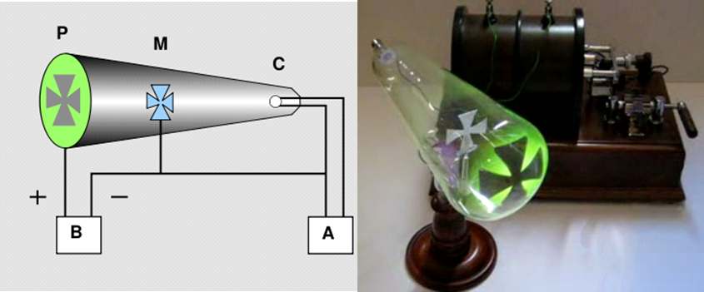

**Deflection of the cathode ray beam**

Since cathode rays are electrons (negatively charged particles) they may be deflected by either an electric field or a magnetic field.

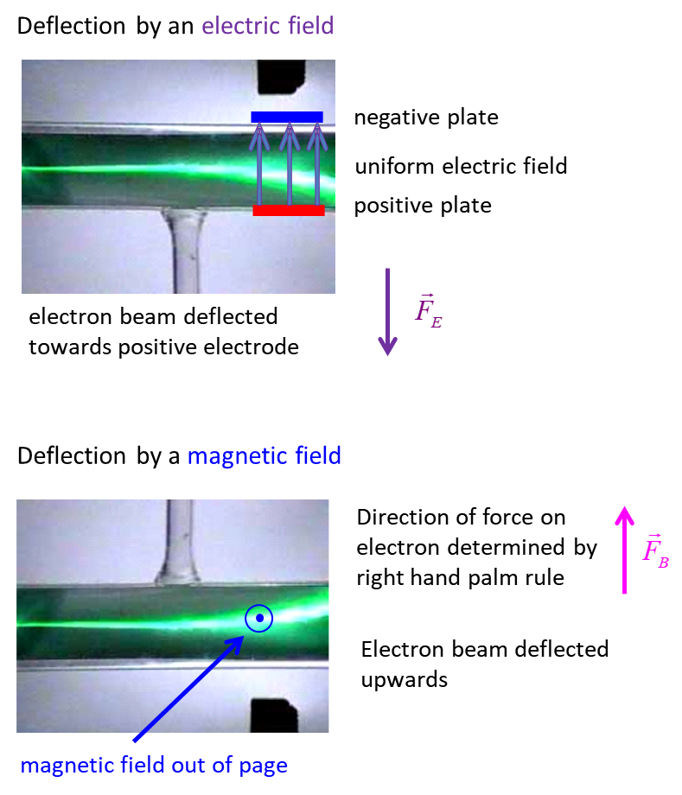

**Paddle Wheel**

When the cathode rays strike a paddle wheel inside the discharge tube, the wheel spins. This shows that the cathode rays possess both **momentum** and **kinetic energy**. The direction of the spin of the wheel showed that the rays travel from the cathode to the anode.

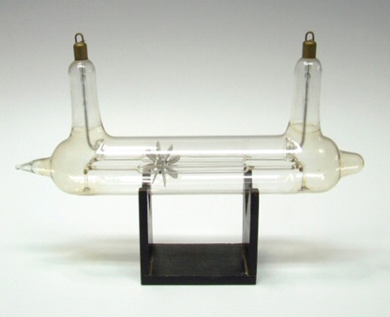

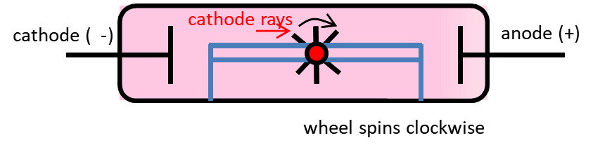

**Spectral tubes**

**(discharge tubes containing different gases)**

In spectral tubes, the light emitted from excited molecules is characteristic of the gas



Spectral tubes: the light emitted from different gases at reduced pressure.

**Geissler tubes**

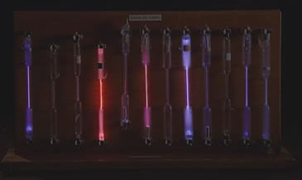

An electrical discharge is passed through a gas at low pressure by the motion of gaseous ions. This results in some very beautiful and interesting visual phenomena due to the emission of radiation.

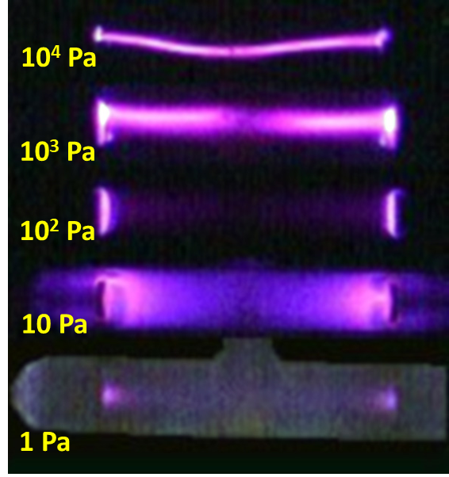

Tubes especially designed to show this are known as **Geissler tubes**. The tubes are usually evacuated to pressures of about 40, 10, 6, 3, 0.14 and 0.03 mmHg.

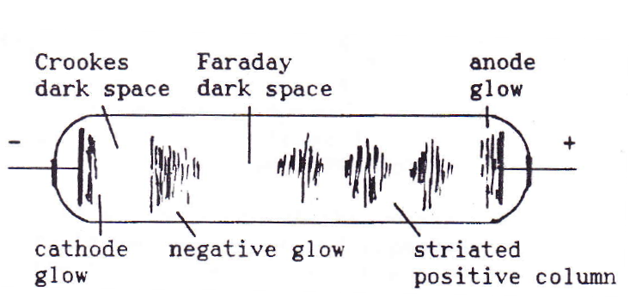

**40 mm Hg** **streamers** of brilliant purple light flickering between electrodes



**10 mm Hg**

Streamer broadens and becomes a mauve colour (**positive column**) – fills tube except for **Faraday dark space** near cathode



**6 mm Hg**

Larger Faraday dark space and shorter positive column (pink)

negative glow near cathode (violet)



**3 mm Hg**

Cathode is covered with a soft reddish glow - the cathode glow

A new dark region - **Crookes dark space** - separates the cathode from the negative glow. Faraday dark space still separates the negative glow from the positive column. Positive column broken up into several bright striations – button shaped with their convex side facing the cathode and are regularly spaced.



**0.14 mm Hg**

Width of the Crookes dark space increases. The negative glow becomes brighter and expands towards the anode. At the same time the positive column decreases and eventually disappears so that the negative glow then fills the tube. Further reductions in the pressure results in further expansion of Crookes dark space and the shrinkage of the negative glow.



**Pressures < 0.05 mmHg**

Crookes dark space fills the tube as the negative glow and positive column disappear. A bright fluorescence is now observed on the wall of the tube near the anode. The colour of the fluorescence is determined by the chemical composition of the glass and not by the nature of the gas in the tube. In ordinary glass the fluorescence is bright green due to manganese. Tubes at these low pressures form the basis of the **fluorescent tube**. The tubes are coated with a fluorescent material.

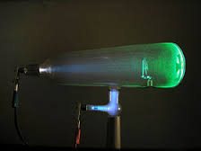

**Pressure < 0.001 mm Hg** - ions and electrons make very few collisions in travelling the length of the tube. The positive ions will acquire a large kinetic energy by the time

they strike the cathode. Because of this bombardment, the cathode emits particles called cathode rays. These cathode rays travel away from the cathode in approximately straight lines which are perpendicular to the surface of the cathode. These cathode rays are electrons.

**EXPLANATION OF THE PATTERNS OBSERVATION IN DISCHARGE TUBES**

**Crookes Dark Space**

In a gas at low pressure, ions can acquire sufficient kinetic energy from a strong applied electric field to cause ionization or excitation of atoms and molecules by collisions. The electric field in the region near the cathode is very high, much higher than in any other part of the tube. This large electric field in the Crookes dark space causes the ionization of many ions and molecules producing free electrons and positive ions. The ions thus formed produce more ionizations. Electrons are also produced by the impact of the rapidly moving positive ions with the surface of the cathode. Since the ions have high kinetic energy, they ionise atoms and molecules more frequently than they excite then. Therefore, little right is emitted. Both negative and positive ions are moved from the space in front of the cathode because of the applied electric field. Since the electrons are less massive than the positive ions they are removed more rapidly. Therefore, an excess of positive ions occurs. This accumulation of positive ions accounts for the large electric field in this region.

**Negative glow region**

The electrons produced in the Crookes dark space accelerate into negative glow region. The negative glow region is characterised by high concentrations of electrons and positive ions. Therefore, the electric field strength is low in this region. Thus, intensive recombinations of electrons and positive ions into neutral atoms and molecules occur. This results in the emission of light by the discharge, i.e., the negative glow is mainly due to a glow of recombination. Positive ions formed in the negative glow are attracted to the cathode and thus maintain the supply of negative ions.

**Faraday dark space**

In this region, there is a low concentration of electrons and ions, hence, the probability of recombination in the Faraday dark space is low. The electrons formed in the negative glow do not acquire sufficient energy to produce fresh ionisations in the Faraday dark space. This is why this region appears dark.

**Positive column**

The current across the Faraday dark space is due mainly due to electrons drawn from the negative glow region. Thus, there is an accumulation of negative charge in this region which produces an increase in the electric field strength until it is sufficiently large to cause fresh ionisations by collisions. This point marks the beginning of the positive column. The glow of the positive column is due to the radiation of excited atoms and molecules (low energy collisions are more likely to produce excitation than ionisation). Most of the transitions are to the ground state. Molecules of different gases emit radiation of different frequencies in such transitions.

***The glow of the positive column has a characteristic colour for each gas.***

The glow from the positive column is used widely in advertising to produce "neon signs". Neon gas discharge tubes produce a red glow, argon ones a bluish-green glow. Most of the recombination between electrons and positive ions occurs at the walls and thus the walls are heated. The positive column is often **striated**. The striations are due the loss in kinetic energy of the electrons in the dark regions and then further excitation of atoms and molecules within the bright band as electrons are accelerated from the dark bands into the bright bands by an increasing electric field.

[View video: Cathode Rays Lead to Thomson's Model of the Atom](https://www.youtube.com/watch?v=2xKZRpAsWL8)

[View video: Discharge tube, Geissler tube, Crookes tube, cathode rays](https://www.youtube.com/watch?v=FIyCbgP-Z6k) Explain your observations

[VISUAL PHYSICS ONLINE](http://www.physics.usyd.edu.au/teach_res/hsp/sp/spHome.htm)

If you have any feedback, comments, suggestions, links or corrections please email:

Ian Cooper School of Physics University of Sydney

ian.cooper@sydney.edu.au